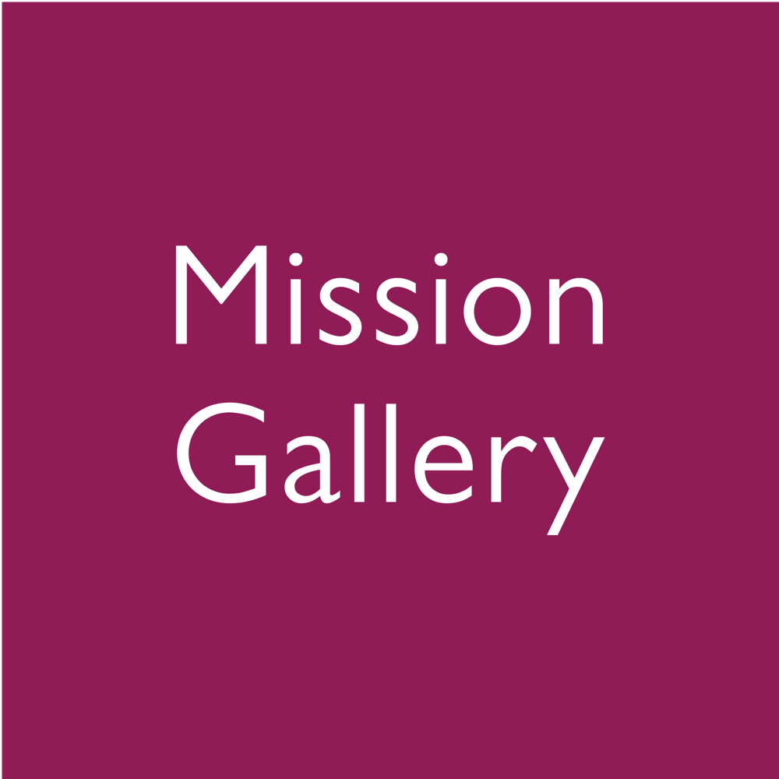

Equalities monitoring

Interaction with Mission Gallery
Please select one of these options:

Post title
Position
Freelance contract role
Participant in which activity
Other (please give detail)

Your Details
Title
Full Name
Date of Birth
Home Address
Email
Landline Number
Mobile Number

Ethnicity
☐ Asian or Asian British - Indian  ☐ Asian or Asian British - Pakistani  ☐ Asian or Asian British – Bangladeshi  ☐ Chinese  ☐ Other Asian background  ☐ Black or Black British - Caribbean  ☐ Black or Black British - African  ☐ Other Black background  ☐ Mixed - White and Black Caribbean  ☐ Mixed - White and Black African  ☐ Mixed - White and Asian  ☐ Other mixed background | ☐ Arab  ☐ Other ethnic background  ☐ White  ☐ White - Scottish  ☐ White - Irish  ☐ Irish Traveller  ☐ White - Welsh  ☐ White - European  ☐ Other White background  ☐ Gypsy or Traveller  ☐ Not known  ☐ Prefer not to say

Religion and Belief
☐ No religion
☐ Buddhist
☐ Christian
☐ Hindu
☐ Jewish
☐ Muslim
☐ Sikh
☐ Spiritual
☐ Any other religion or belief
☐ Prefer not to say

Any other religion or belief:………………………………..

Sexual Orientation
☐ Bisexual
☐ Gay
☐ Lesbian
☐ Heterosexual
☐ Other
☐ Prefer not to say

Other:………………………………..

Disability
Under the Equality Act 2010, you are considered disabled “if you have a physical or mental impairment that has a ‘substantial’ and ‘long-term’ negative effect on your ability to do normal daily activities.”
- ‘Substantial’ is more than minor or trivial, e.g. it takes much longer than it usually would to complete a daily task like getting dressed
- ‘Long-term’ means 12 months or more

Do you consider yourself to be a disabled person? Yes ☐ No ☐
Do you consider that you have a long-standing health condition? Yes ☐ No ☐
If yes, please indicate what your long-standing health condition is:  ☐ Two or more impairments and/or disabling medical conditions  ☐ A specific learning difficulty such as dyslexia,  dyspraxia or AD(H)D  ☐ General learning disability (such as Down's syndrome)  ☐ A social/communication impairment such as Asperger's syndrome/other autistic spectrum disorder  ☐ A long standing illness or health condition such as cancer, HIV, diabetes, chronic heart disease, or epilepsy | ☐ A mental health condition, such as depression, schizophrenia or anxiety disorder  ☐ A physical impairment or mobility issues, such as difficulty using arms or using a  wheelchair or crutches  ☐ Deaf or serious hearing impairment  ☐ Blind or a serious visual impairment uncorrected by glasses  ☐ A disability, impairment or medical condition that is not listed above  ☐ Prefer not to say

Work Permit
Do you require a work permit to work in the UK? Yes ☐ No ☐

If yes, do you currently hold a work permit to work in the UK? Yes ☐ No ☐

If yes, please state the nature of your work permit and its expiry date:

Rehabilitation of Offenders
Do you have any convictions, cautions, reprimands or final warnings that are unspent under the Rehabilitation of Offenders Act 1974 and which are not “protected” as defined by the Rehabilitation of Offenders Act 1974 (Exceptions) Order 1975 (as amended in 2013)?

Yes ☐ No ☐
If yes, please provide details:

Where a job falls within one of the excluded categories under the Rehabilitation of Offenders Act 1974, disclosure of any spent convictions is required and any offer of employment, if made, will be subject to a DBS (Disclosure and Barring Service) check.

Further information can be found on the Government website: Updated guidance on the Rehabilitation of Offenders Act 1974.

Privacy Notice

Individuals are requested to provide the following information for records purposes and to enable Mission Gallery to meet our statutory equality obligations. The information you provide us is kept in the strictest of confidence and treated in accordance with the Equality Act 2010.

The information provided will be processed in accordance with the Data Protection Act 2018 and will not be used in the selection process.

Mission Gallery is committed to respecting and protecting your data. We have a number of safeguards to protect your data, in accordance with the Data Protect Act 2018 and GDPR legislation. If you have any questions, please contact us at: info@missiongallery.co.uk

Overview of data usage

The following have access to the data:
- Creative Director
- Board of Directors

The data collected is used for:
- Monitoring equality.
- Making reasonable adjustments to meet our statutory equality obligations.

Data may be shared with the following 3rd Parties:
- Arts Council of Wales.

