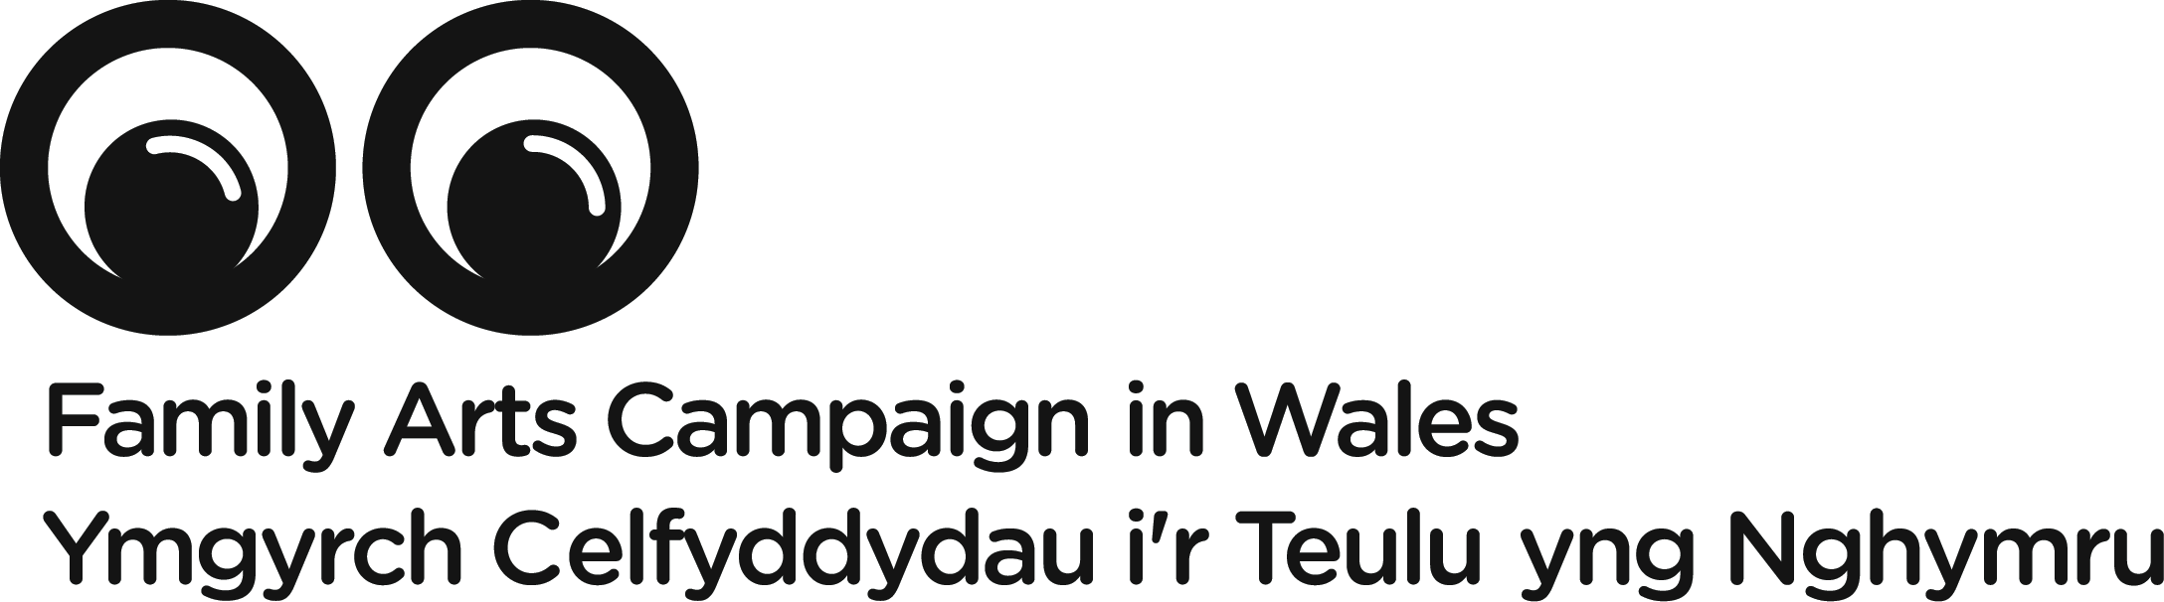

Creative workshop for practitioners

This is a professional development opportunity for practitioners and producers involved in making work and designing activities for community involvement.

Led by David Chambers of Aberrant Architecture
Saturday 19 November 2016
11am - 4pm
Mission Gallery, Swansea

In this creative and practical workshop, David Chambers will lead participants in exploring and developing innovative ideas to reflect and reveal embedded local knowledge within a particular place. We will share techniques to uncover unique spatial and cultural histories and the desires of the people who live and work there.

The collaborative and narrative-based processes utilised by Aberrant Architecture will be explored and discussed, alongside a surprising and colourful survey of historic participatory processes. Such strategies will be collectively reappraised from a realistic contemporary perspective. Considering day-to-day issues for communities and for practitioners, participants will identify and test what we can learn from these historic case studies and evolving methodologies.

To find out more about the work of Aberrant Architecture, please visit www.aberrantarchitecture.com

The workshop will be participatory and is designed to offer practitioners time and space and stimulus to explore ideas and share experiences with peers.

This is a free workshop for a limited number of creative practitioners. It is supported by the Arts Council of Wales and managed by the Family Arts Campaign in Wales. Priority will be given to practitioners who are either based in or have a professional relationship with organisations in Wales.

Please submit the attached expression of interest form and send it to familyarts@fieldworking.co.uk by Friday 11 November if you would like to join David on Saturday 19 November.

David Chambers

David is the Director of the award-winning practice Aberrant Architecture. Aberrant Architecture is a multi-disciplinary studio and think tank that operates internationally in the fields of architecture, design, contemporary art and cultural analysis.

Aberrant have built numerous projects and exhibited work at international architecture exhibitions including the Venice Biennale of Architecture, Gwangju Design Biennale and Hong Kong & Shenzhen Architecture Biennale. Their work has been collected by the Museum of Art in Rio de Janeiro.

In 2010, Aberrant was the first architecture practice to be appointed ‘Designer in Residence’ at the V&A Museum. In the same year the practice co-founded The Gopher Hole, a gallery in London.

David Chambers is co-founder of Aberrant Architecture and also a studio leader at Central Saint Martins. He studied architecture at Bath University, where he received the Barton Willmore Prize for Innovative Design; at the Royal College of Art and at T.U. Delft.

Expressions of interest

Please complete and send the form below to familyarts@fieldworking.co.uk by Friday 11 November 2016. Places on the workshop are limited and so whilst we hope we will be able to accommodate everyone who expresses an interest in attending there is a chance that we may not have capacity for all. We will confirm with you as soon as possible whether your place is secure or on a waiting list.

Many thanks.

Creative workshop for practitioners

Expression of interest

Name

Practice or medium with which you work

Email contact

Telephone contact

Where you are based

Number of years experience in family / community arts practice

What aspect interests you about this workshop?

Any special requirements

Any food allergies

Please sign / write your name to confirm your availability and commitment to attend the full workshop

